 |  |  | Date Due: August 31, 2016
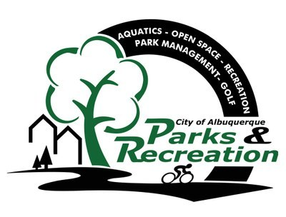 | City of Albuquerque, Parks and Recreation  City Sports Team Roster  TEAM NAME: YEAR: 2016 | SEASON: -Spring -Summer -Fall -Winter  SPORT: -Softball -Flag Football -Basketball  GENDER: -Coed/Mixed -Men's -Women's  LEAGUE/LEVEL:
I, the undersigned, agree to indemnify, defend and hold harmless the City of Albuquerque, against any and all damages to property or injury to, or death of, any person, including property or employees of the City of Albuquerque and from any and all claims, demands, actions, suites, or proceedings of any kind or nature. I assume all risk of injury to my person and property that may be sustained in connection with any activity in and about the premises. I am in good health and have no physical condition that would prevent me from participating. I am familiar with the skills required to participate. I further agree to practice and display good sportsmanship at all times and agree to abide by the “Player/Participant Code of Conduct” and fully waive all rights associated with the “Player Code of Conduct.” I have read the Waiver of Liability and fully understand its terms, conditions and meaning.

 | Player’s Name (Print or Type) | Player’s Signature or Parent/ Guardian Signature (if a minor) | Phone# | State (license or identification card) ID # | Check if Previously Signed  “Player Code of Conduct”
1.
2.
3.
4.
5.
6.
7.
8.
9.
10.
11.
12.
13.
14.
15.
16.
17.
18.
19.
20.
Manager Name: |  | Mgr Email: |  |  | Manager Signature:
Street Address: |  | City: |  | State: |  | Zip Code:
Mgr Phone (H): |  | Phone(W): |  | Phone(C):
Alternate Contact: |  | Alt Email: |  | Alt Phone:

For Official Use Only
Explanation Amount Cash/Check/CC Date Receipt # Initials

